## PART 1 – TASK 1

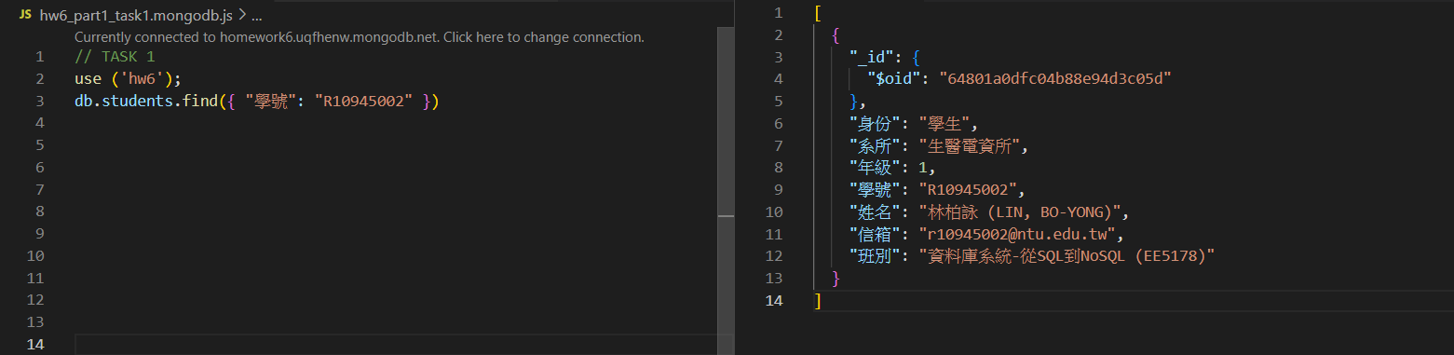

## PART 1 – TASK 2

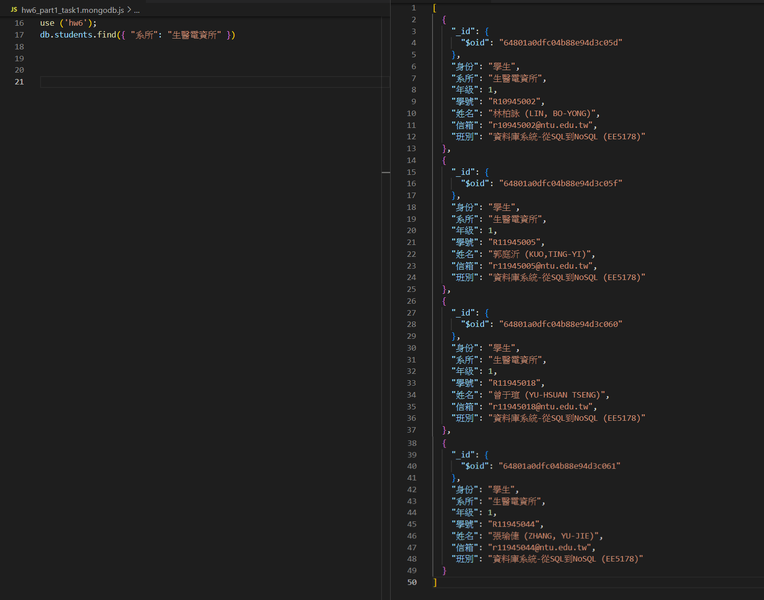

## PART 1 – TASK 3

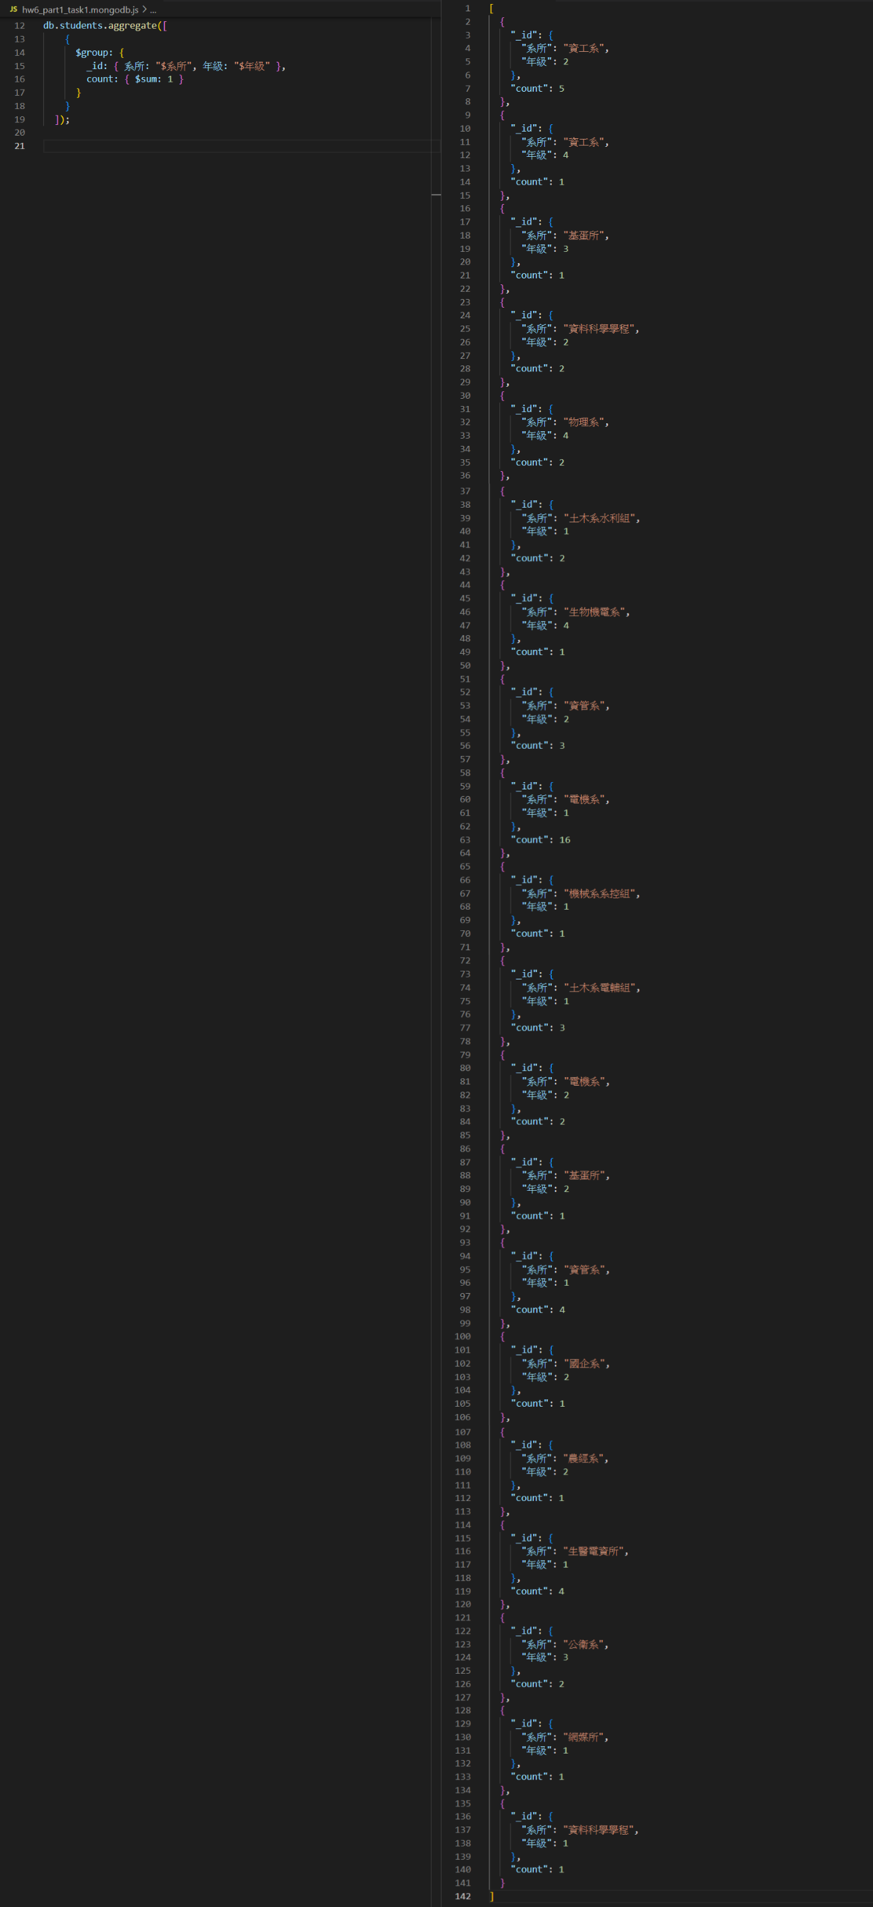

## PART 1 – TASK 4

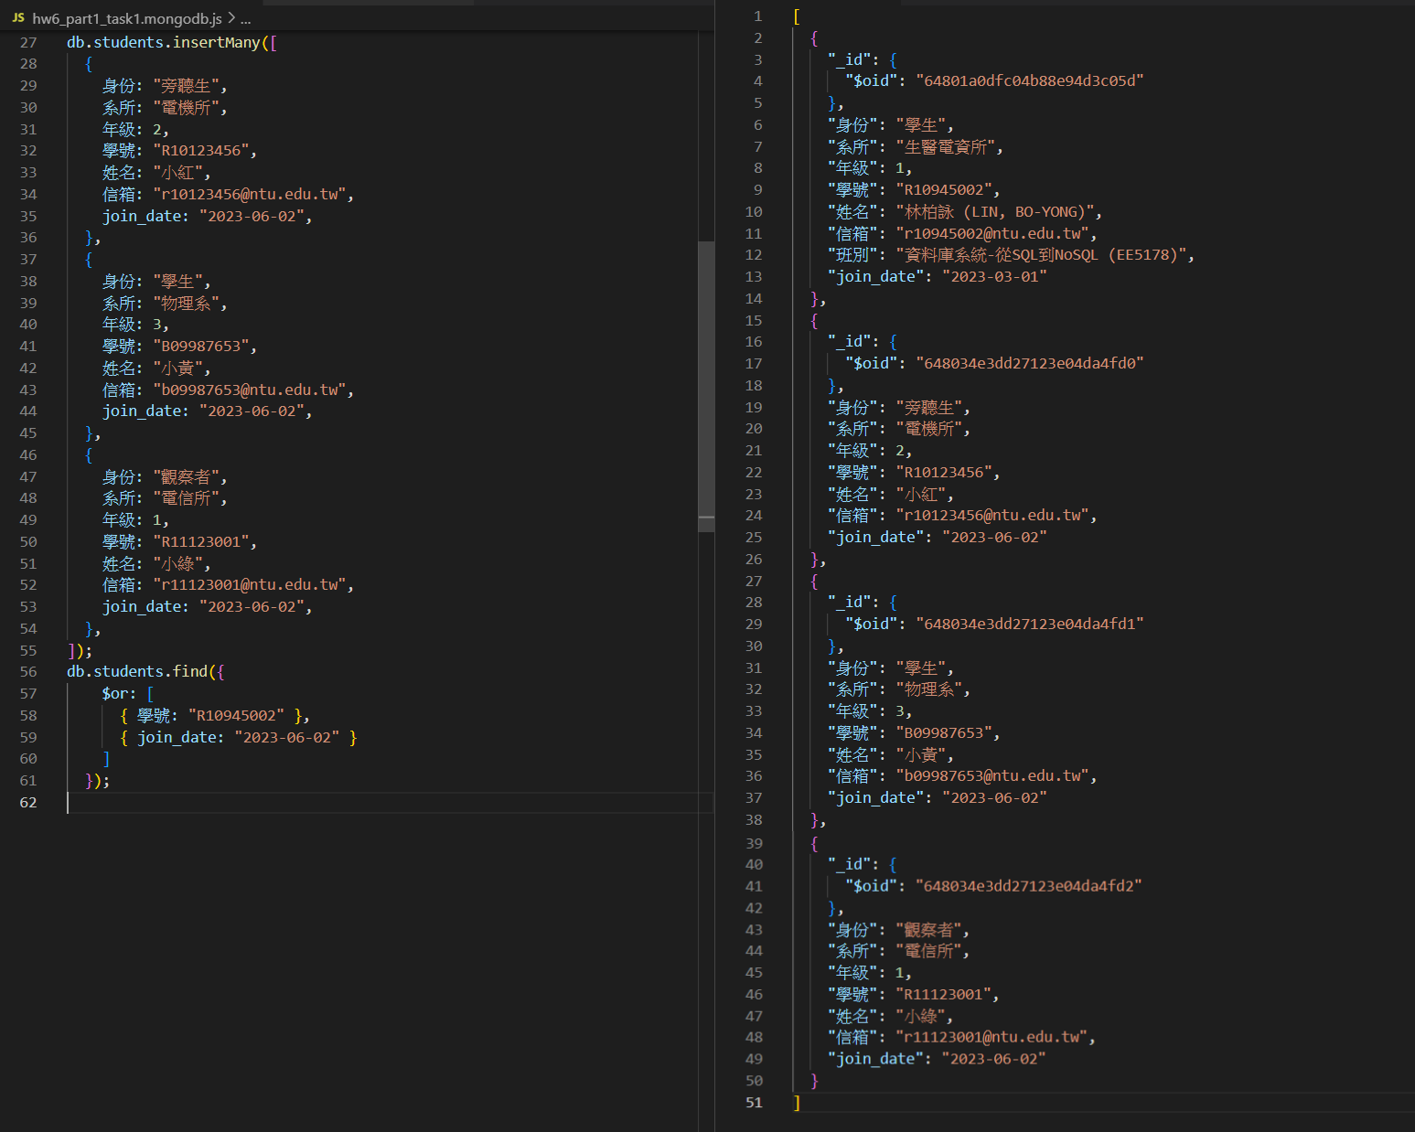

## PART 1 – TASK 5

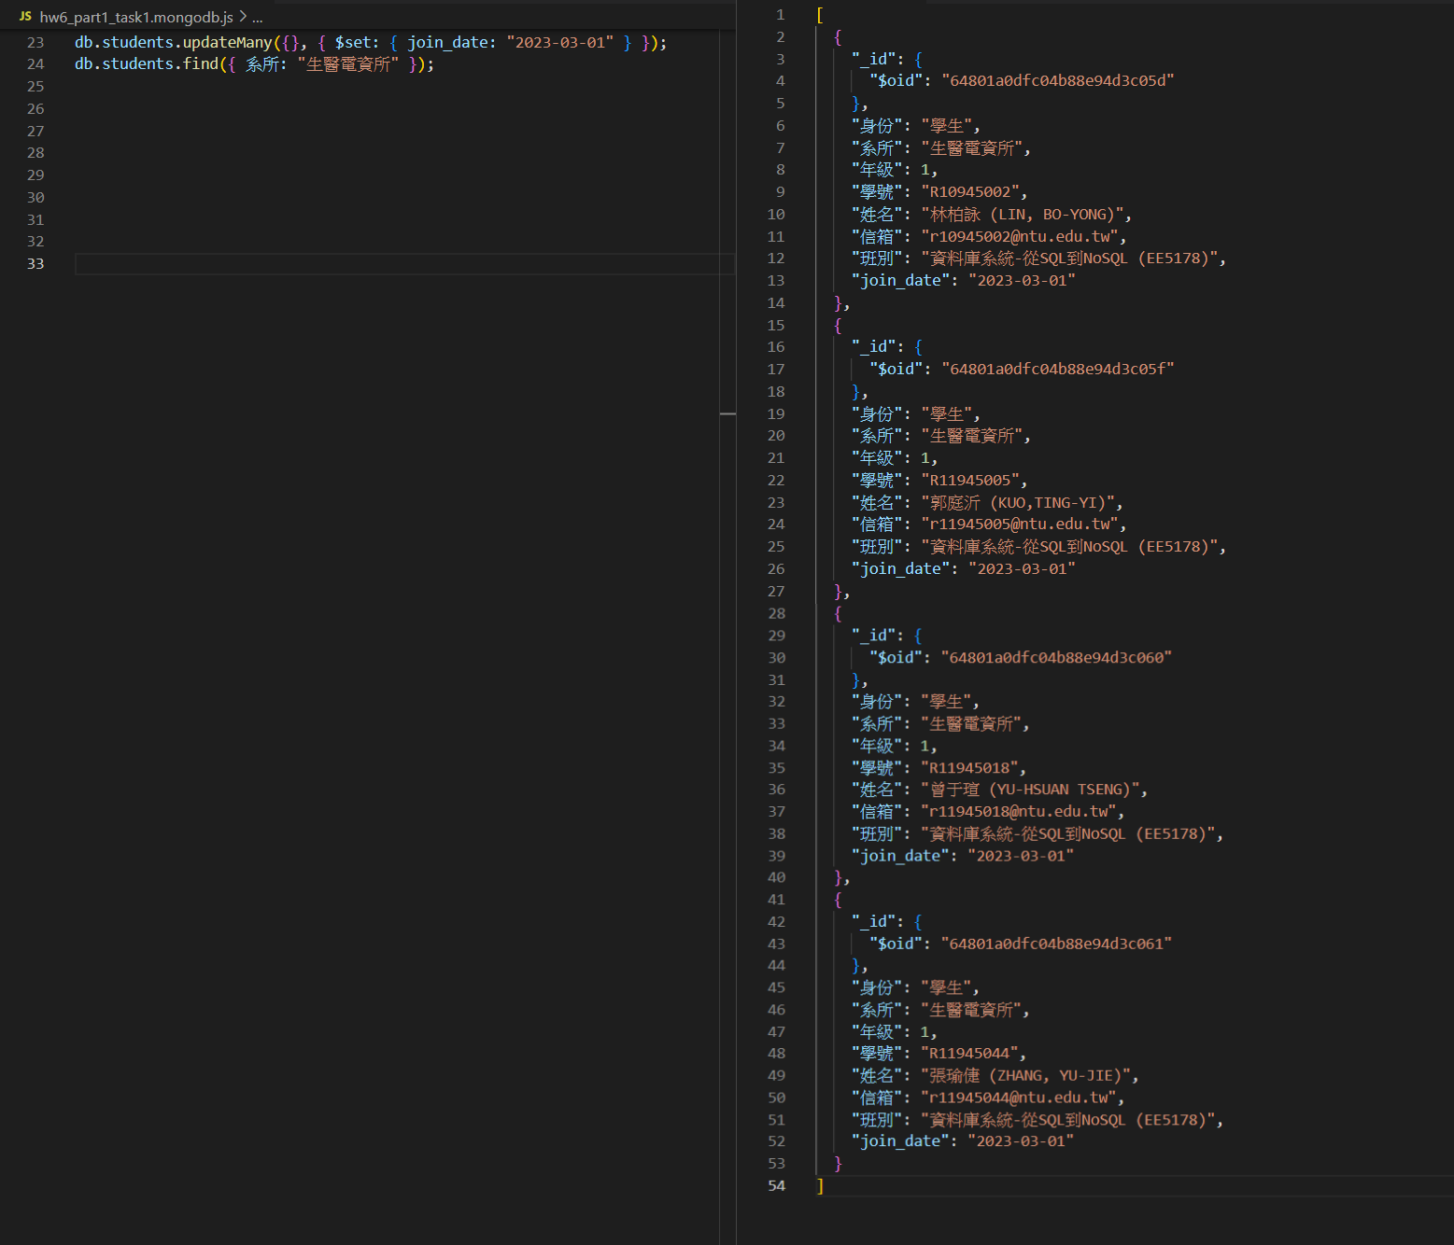

## PART 1 – TASK 6.1

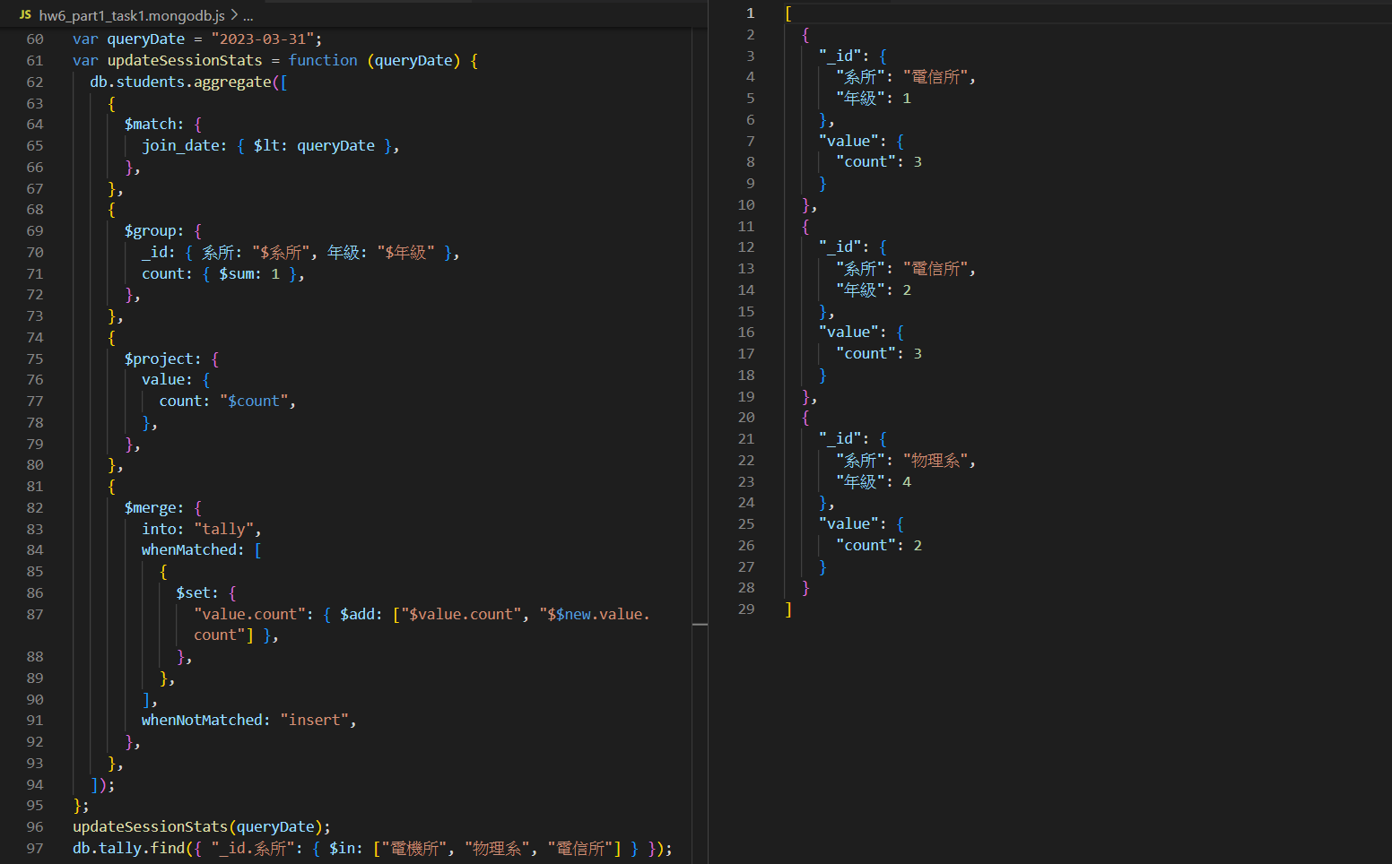

## PART 1 – TASK 6.2

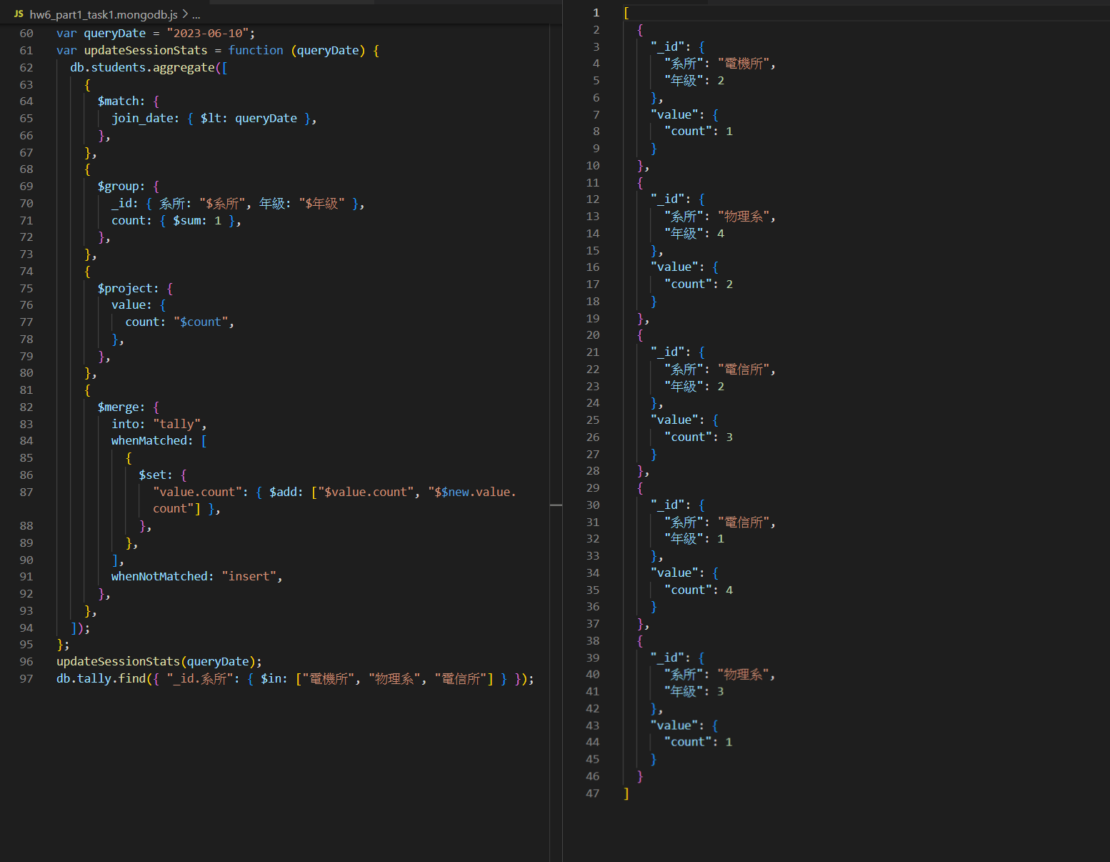

## PART 2 – TASK 1